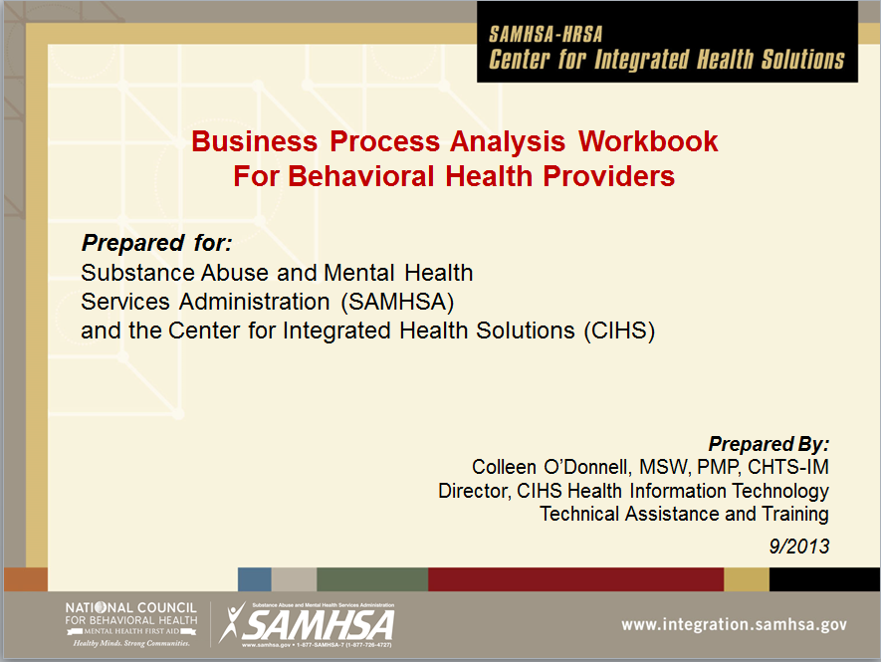

Introduction

*The Business Process Analysis document is a snapshot in time of how an organization conducts day-to-day activities. It is comprised of the discrete Workflow Diagrams (Part 2) paired with the corresponding Business Process Narrative (Part 3).*

*The finished product has enormous utility. It can be used to analyze activities for improved efficiency, effectiveness and quality of care, to validate agreement on how workflows should be conducted, for change management, PDSA, training, implementing the EHR, validating the configuration, conducting gap analysis, and for capturing the valuable analysis that naturally occurs when a workflow is first diagrammed. Part 1of this work book provides an overview of how to build the Business Process Analysis in full.*

*The Business Process Narrative captures the discussion and comments that are made when the “As Is” workflow is diagrammed and the desired “To Be” state is conceptualized. There is a great deal of valuable information shared in these settings that will be lost if it is not recorded. For this reason, there needs to always be someone in the analysis processes who is responsible for monitoring and recording these insights, ideas, and critical information, organizing them into critique (“As Is”) and vision (“To Be”).*

*By the way, to make this workbook useful as a template for your organization, instructional text is included using textboxes like this one. When you are ready, you can delete the textboxes and start with a clean template.*

Business Process Analysis Workbook

**Part 1 (of 3) - Foundation**

**Understanding the Business Process Analysis**



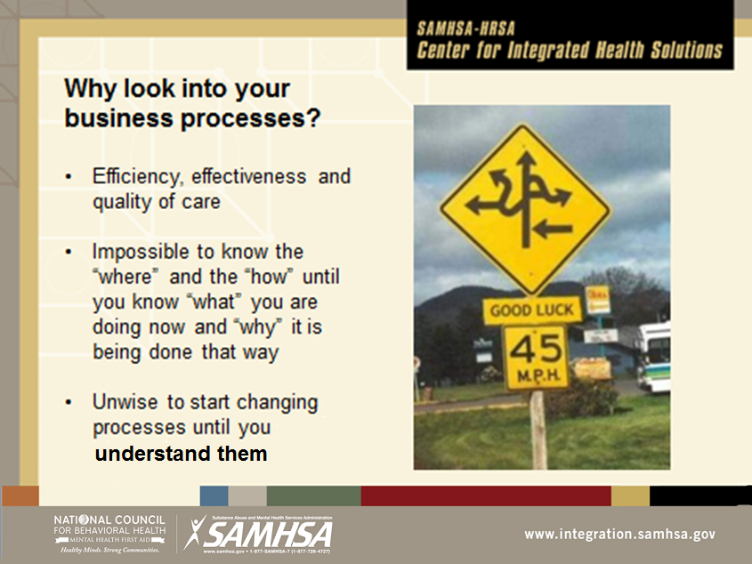

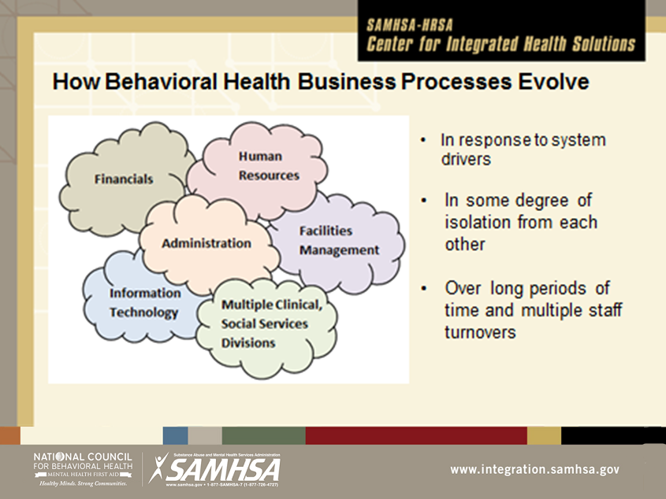

Most Behavioral Health Provider organizations are composed of multiple divisions and departments that may work well together where they intersect, but do not have a shared understanding of what anyone outside of their area does from day to day.

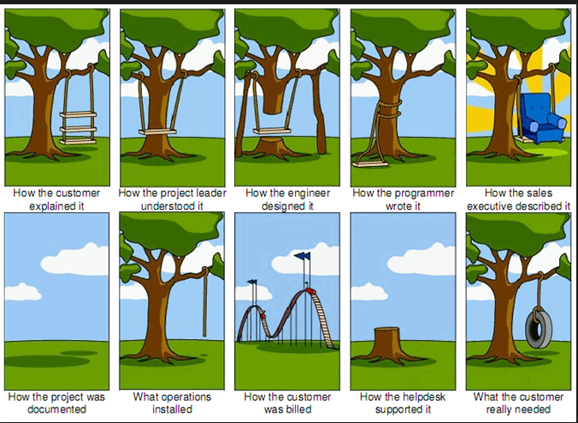

Since everyone is operating from a unique perspective and with incomplete information there are many opportunities for communication to breakdown.

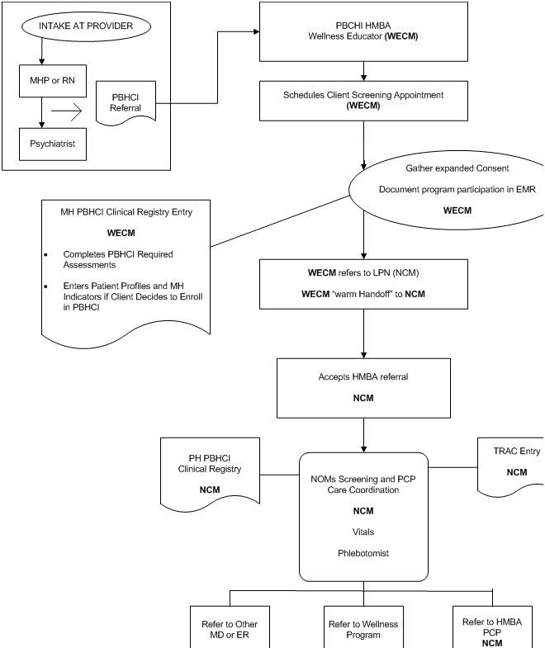

One way to increase shared understanding is by creating workflow diagrams. But without a focus on clear communication these diagrams are often only understandable by the person who did the work.

EXAMPLE OF INEFFECTIVE WORKFLOW DIAGRAMMING

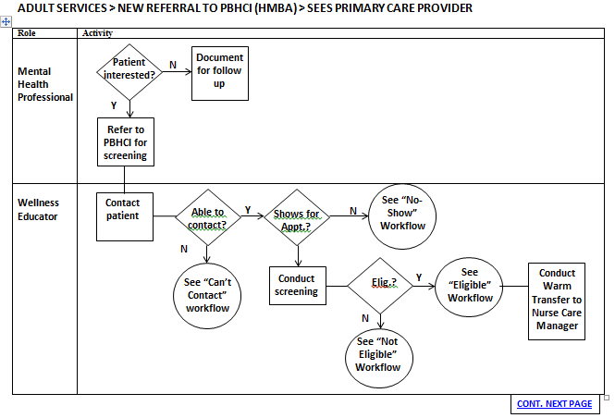

This is the same workflow, but translated into the “swim lane” model for diagramming. It starts with a clear identification of the workflow to be studied, uses two columns for “Role” and “Activity” and limits shapes to rectangles, diamonds and circles.

This page and the next show how the ineffective workflow diagram on the previous page was redrawn using this approach.

EXAMPLE EFFECTIVELY DIAGRAMMED AND READY FOR ANALYSIS

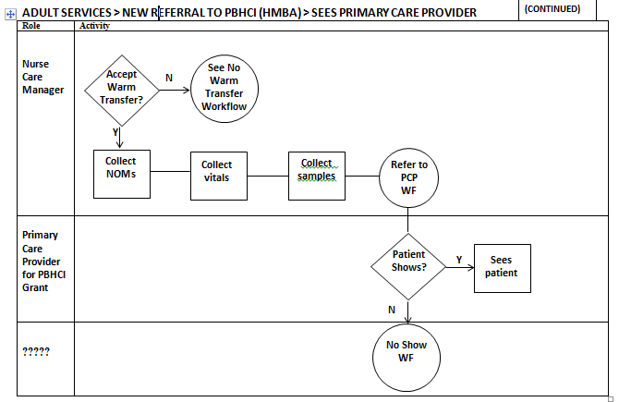

Now it is very easy to see what roles are responsible for different activities. You can see on Page 9 that sometimes a decision point includes more than one possibility –this is represented as another decision point. There can be several decision points in a row, each with its own “Yes” and “No” arrow.

Think of the two different types of diagrams as swimming pools. On page 8 it is as though everyone jumped into the pool and started doing their own thing. In the swim lane model, the staff is identified by Roles on the “platform” and the Activities they complete stay in their swim lane.

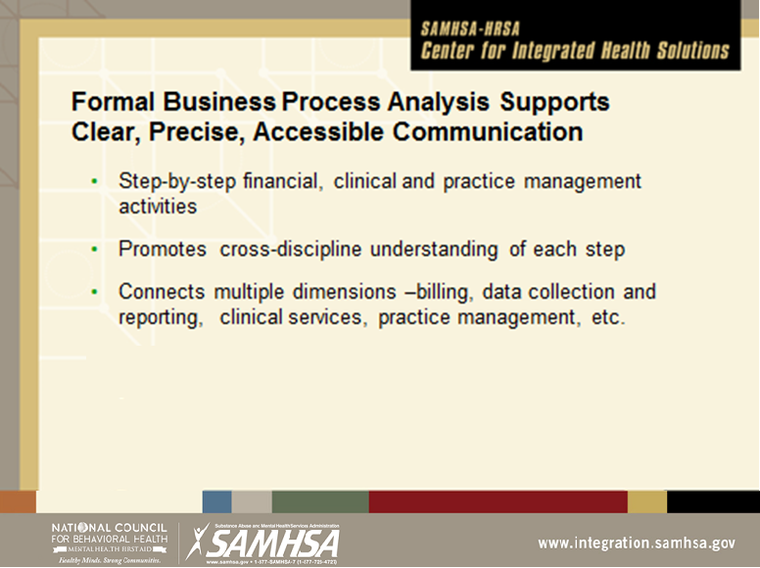

There is an “opportunity cost” associated with creating these workflows and conducting the analysis – but there are many valuable outputs from the process that pay dividends over a relatively short period of time.

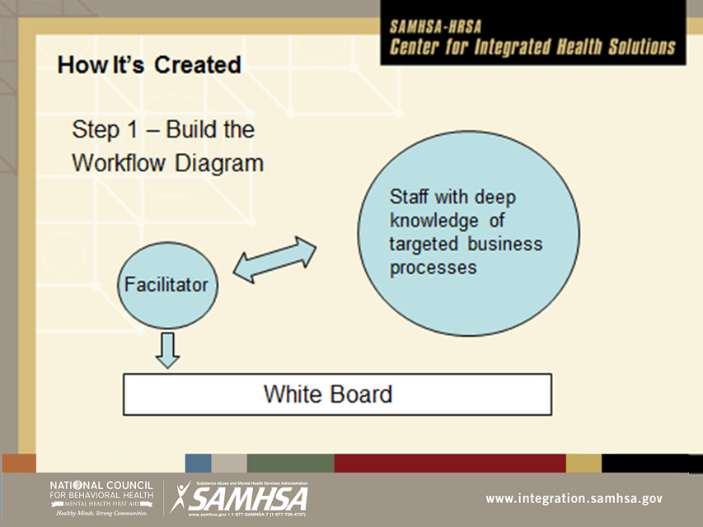

The best way to build the diagrams is to gather the individuals together who implement the workflows, and have them explain what they do to someone who is not so familiar with the process. This person acts as the facilitator, slowing down staff who rattle off their daily routine in rapid fire fashion. This ensures accuracy in the workflow represented in the diagram.

It can be difficult to persuade administration of the value of this effort – after staff acquires the skill, administration should sit in on at least one session to see what goes on and why it is so valuable.

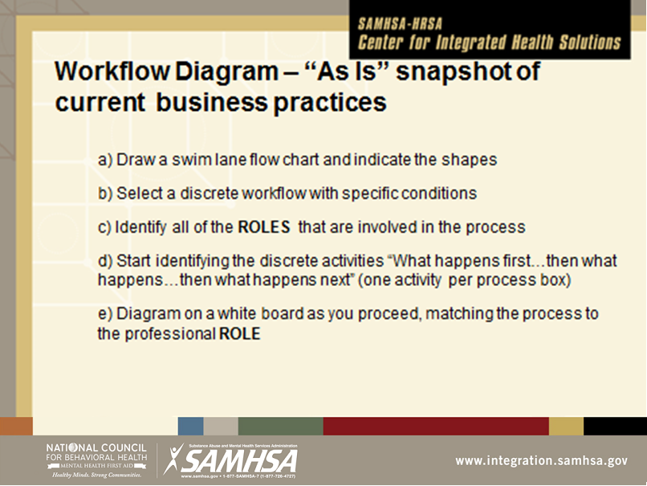

The swim lane workflow links the professional roles with their discrete activities. This allows for a very efficient analysis of tasks by credential and position description. For example, on page 10 we can clearly see that the Nurse is collecting and entering data. This is not an appropriate task for this role because they could be providing billable services instead, and also because the task can be completed by someone who costs less per hour and whose skills are a better match.

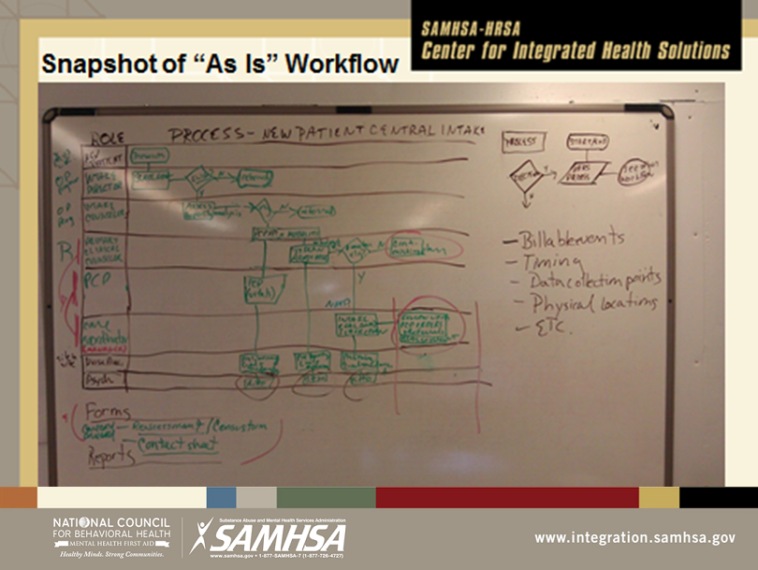

Creating the diagram is usually a bit messy, but it can be cleaned up later either by drawing out the workflow neatly by hand or by recreating it in workflow software such as Visio. All of the workflows in this workbook were created using MS Word. Don’t waste time copying the finished diagram – just take a snapshot with a phone camera and move on to the next task.

**Diagramming workflows is covered in detail in Part 2 of this Workbook.**

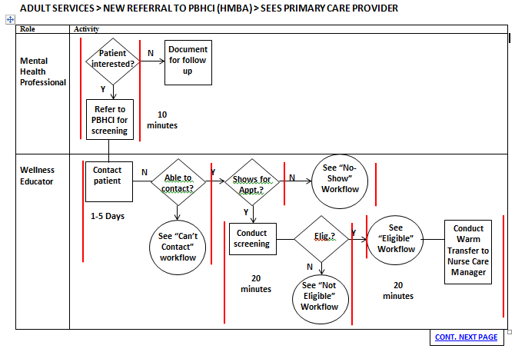

You can use colored lines to help isolate each specific step in the process for analysis. In this instance, the steps have been analyzed for time. The analysis revealed multiple inefficiencies, barriers and missed opportunities. Go to page 41 for the revised “TO BE” workflow. **The “TO BE” workflow will be implemented and modified using PLAN/DO/STUDY/ACT (PDSA).**

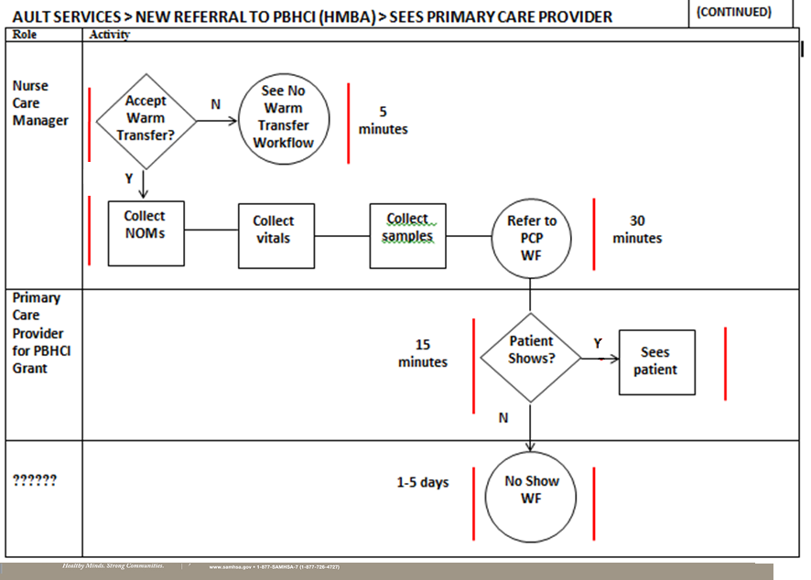

It is much easier now to see what roles are responsible for each activity, and where the various decision points are. Now that the workflow is effectively diagrammed, it is possible to conduct a thorough analysis

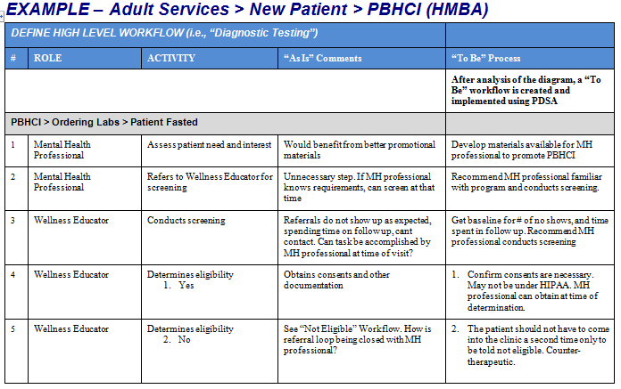

The Business Process Narrative is covered in detail in Part 3. For right now, it is important to understand that, as the workflow is being analyzed, a great deal of valuable discussion goes on that has to be captured. There is identification of inefficiencies and barriers but also the generation of insights and ideas for improving the workflow. The vehicle for capturing this is the Business Process Narrative, composed as the workflows are actually diagrammed. The roles and individual activities are listed in the first two columns, the issues are identified in the third column labeled “As Is” and the ideas for improvement are identified in the last column labeled “To Be.”

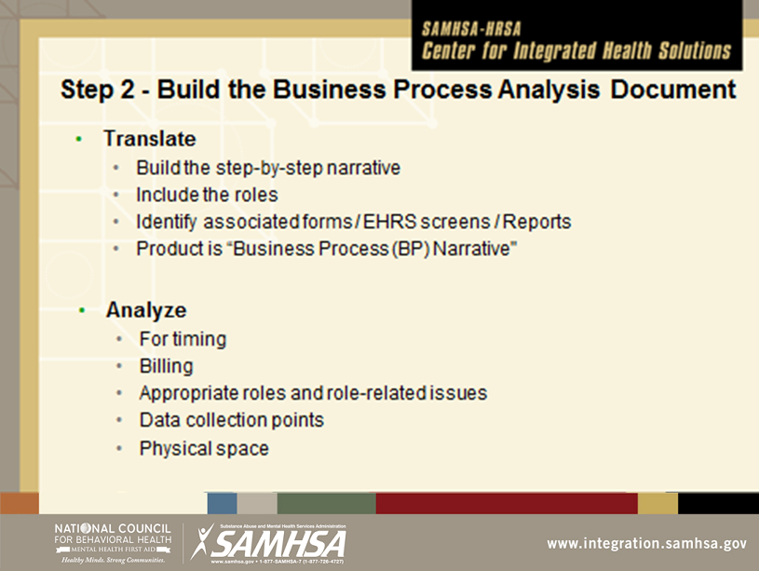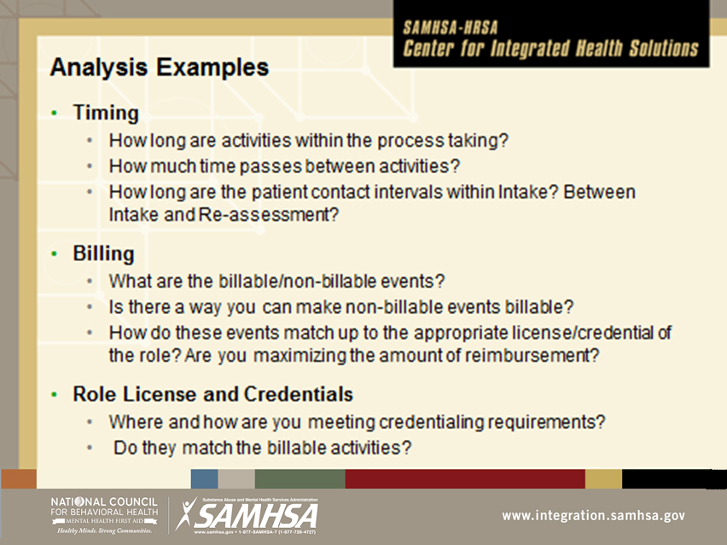

Since completing forms, submitting invoices for reimbursement and the need to populate reports and patient charts drive so many workflows, there is space in the business process narrative to identify all of the forms, reports and invoices that are associated with that particular process.

When the workflow is diagrammed, the analysis can begin. Resist the temptation to start analysis before the diagram is complete, and keep an eye on the clock.

A single workflow can be analyzed several times for many different factors. For example, do the roles, credentials and activities match up? In the diagram on page 18 we can see that the Nurse (who is a Nurse Practitioner) is collecting and entering NOMs data and vital signs. In analyzing for billing, you would notice right away that data collection and entry (NOMs) is not a billable service and the NP’s time and (billable) skills should not be wasted in this way.

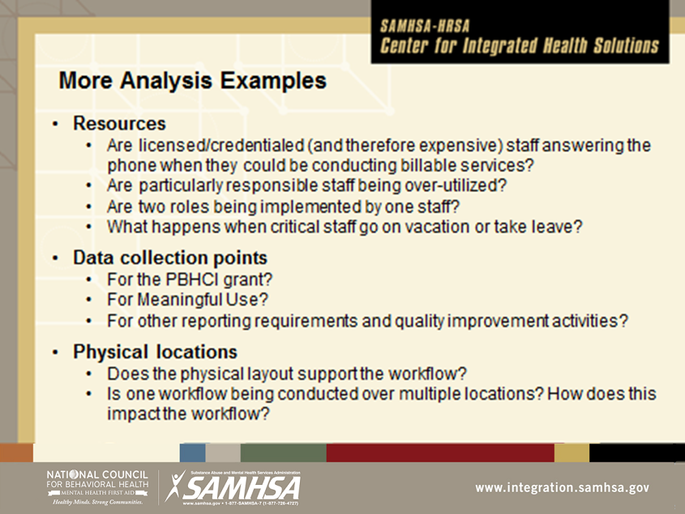

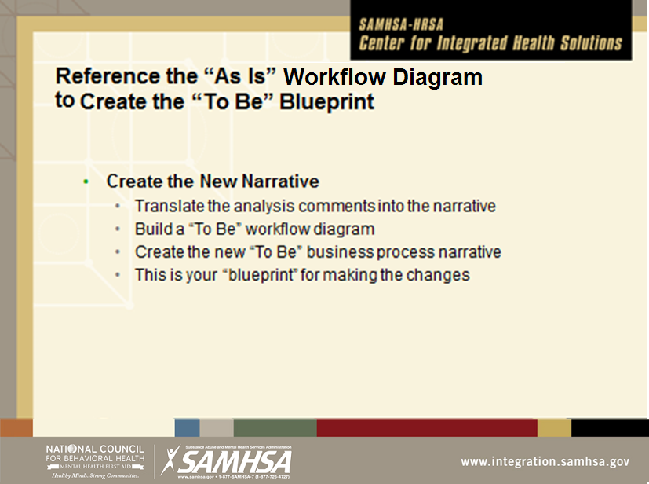

It is very important that the facilitator be allowed to effectively moderate the discussion. Otherwise, those involved will either quickly lose sight of the task and/or strong participants will dominate the analysis. In both cases, real information is lost and valuable time is wasted. Sometimes the facilitator must step in with a firm hand to stop “off task” discussion and return to the task at hand.

There must be decision-makers at the table who have the authority to make changes in workflows, but the staff implementing the workflow must feel free to talk about what they actually do without fear of consequences. Sometimes staff need to be drawn out to talk about workflows, but the effort is invariably worth it. They almost always have some of the best ideas for the “To Be” blueprint.

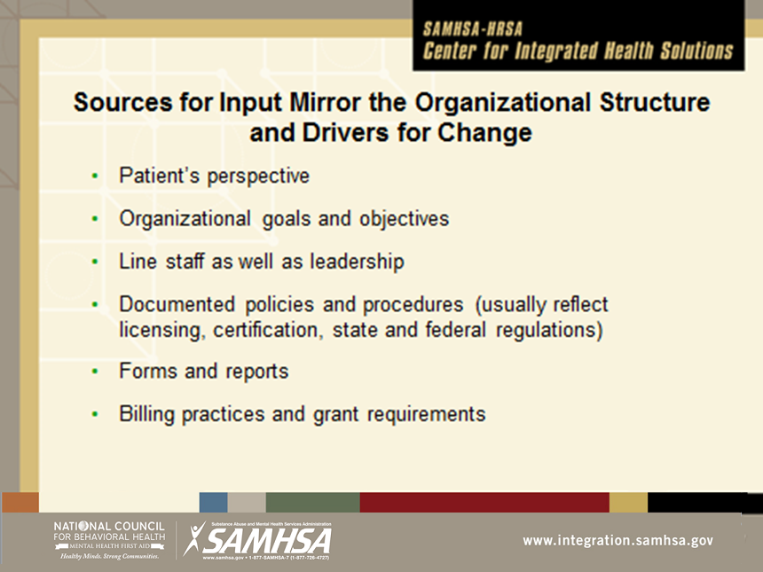

There are many sources for input into the analysis. Policies and procedures should be updated and available. Forms, reports and billing tools should be on hand for reference. Since workflows are very closely tied to billing processes, an authority on the nuts and bolts of finance should be included.

Workflows should not be designed to be optimal for staff – consult the organization’s mission and values, then walk through the proposed “To Be” workflow from the patient’s perspective. If you would hesitate to ask a close friend or loved one to navigate the workflow, it is probably built for the staff’s convenience.

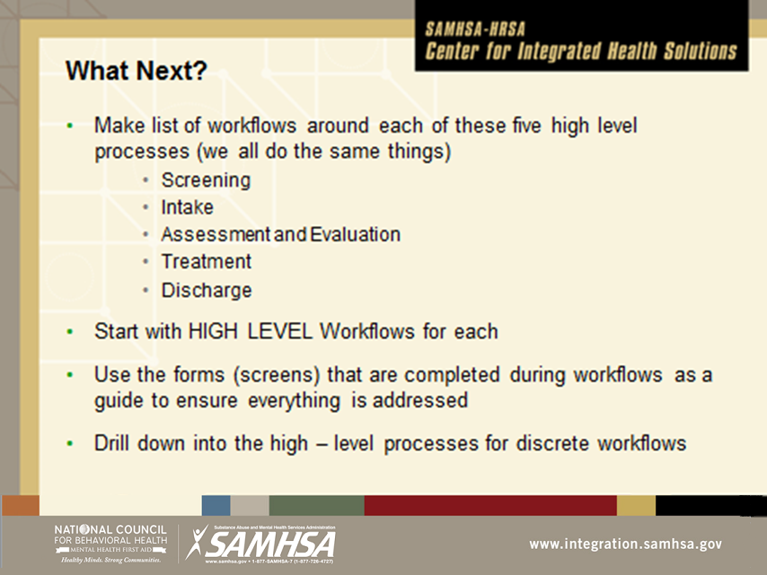

It can be hard to know where to start. The first few sessions should be kept as simple as possible, since the first task is to acquire the skill of workflow diagramming. You may even want to start with something not related to the organization, such as the process each individual goes through to do laundry or their routine when they return home from work. Once everyone is comfortable with the tools, the real work can begin, but the facilitator should stick to high level workflows at the beginning. You can return to any one of the activities and decision points in the diagram to drill down into what happens to obtain as much granularity as needed.

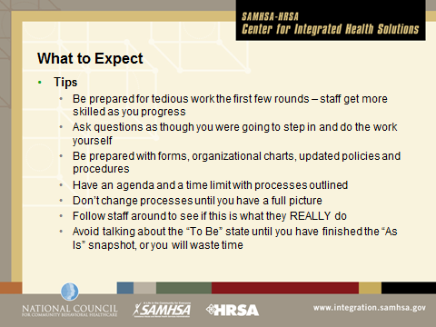

Some staff like doing workflows and quickly become very skilled at it. Take advantage of this and ensure they have lead roles in the development of the Business Process Analysis document. Keep bored staff engaged by asking questions.

The typical questions that are asked in the development of the diagram are “What happens **first**,” then, “What happens **next**?” and throughout the process “Is that what **usually happens**?”

Often an activity that happens first (for example, answering the phone) may have several possible answers to “what happens next?” Start with the answer to the question that is most common or most frequent (what usually happens?) and diagram that. You will find that with small modifications this diagram can be used to illustrate all of the other possible answers to the question.

Business Process Analysis Workbook

**Part 2 (of 3) – Diagramming Workflows**

**Using the “Swimlane” Workflow Diagram to**

**Communicate and Analyze Discrete Workflows**

**Why “Swimlane?”**

|  |  |
| --- | --- |
| **Swimmer’s platform** | **Swimming pool** |
| Michael Phelps | The “swimmer” stays in their lane. Only the patient moves from one lane to the next. |
| Ryan Lochte | In the “ineffective workflow” example on page 8, no one has a lane. Roles are hard to identify, and everyone is in the pool at what seem to be random places and at the same point in time. Decision points are not identified and there are multiple lines drawn from the same shapes, and shapes are used that are subject to interpretation. It very difficult to even understand what is going on, let alone effectively analyze it. |

**Tips for Diagramming Workflows**

* **Review the Part 1 Presentation**
* **Start by defining a high level workflow. The definition can be refined if necessary as you go.**
* **Create the Swimlane Diagram**
* **List the roles in the workflow.**
* **Remember just one line in and one line out of the rectangle and EHR activities, and the “See Other Workflow” circle.**
* **If you want to use more lines than that, you usually have a workflow within a workflow and need to use a circle, or else there is a Decision Point.**
* **Two arrows come out of the Decision Point labeled Yes and No. It usually looks like this:  
  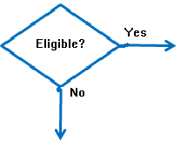**
* **The arrows then point to the activities that would follow the decision**

***DEFINE WORKFLOW _______________________________________________________________________***

|  |  |
| --- | --- |
| **Role** | **Activity** |
|  |  |
|  |  |
|  |  |

**SEE OTHER WORKFLOW**

**Yes**

**No**

**EHR ACTIVITIES**

**DECISION POINT**

**Arrows are used to connect the Decision Point with Activities**

**Lines are used to connect shapes to each other**

**Identifies a single activity in a series of activities. No more than one line going in. No more than one line coming out.**

**ACTIVITY**

**Identifies Decision Points in a series of Activities. Only shape that uses arrows! One arrow marked “Yes” and one arrow marked “No”**

**Activities completed by the role using the EHR (i.e., ePrescrib-ing). Using this shape is optional.**

**Workflow embedded in a high level workflow (i.e., NOMs interview in example on page 10)**

***WORKFLOW FOR PRACTICE_________________________________________________________________***

|  |  |
| --- | --- |
| **Role** | **Activity** |
|  |  |
|  |  |
|  |  |
|  |  |
|  |  |

**SEE OTHER WORKFLOW**

**EHR ACTIVITIES**

**Yes**

**ACTIVITY**

**DECISION POINT**

**No**

***WORKFLOW FOR PRACTICE_________________________________________________________________***

|  |  |
| --- | --- |
| **Role** | **Activity** |
|  |  |
|  |  |
|  |  |
|  |  |
|  |  |

**SEE OTHER WORKFLOW**

**EHR ACTIVITIES**

**Yes**

**ACTIVITY**

**DECISION POINT**

**No**

(For Practice)

Workflow:

|  |  |
| --- | --- |
| **Role** | **Activity** |
|  |  |
|  |  |
|  |  |
|  |  |
|  |  |

Business Process Analysis Workbook

**Part 3 (of 3): Business Process Narrative**

**Capturing the Analysis of the “As Is” State**

**to Create the “To Be” Conditions**

**EXAMPLE/TEMPLATE**

**Business Process Analysis Document**

Organization name

Address

Address

Prepared by:

XXXX

Table of Contents

Document Tracking 34

Post-Validation Changes 35

Introduction 36

Describe Project Scope and Time Frame 36

Business Analysis Process Participants 36

Organizational and Program Structure 37

Business Process Narrative 38

DEFINE HIGH LEVEL WORKFLOW 38

Example: Adult Services > New Patient > PBHCI (HMBA) 38

REFINE THE HIGH LEVEL WORKFLOW 38

EXAMPLE: PBHCI > Ordering Labs > Patient Fasted 38

LIST THE FORMS (OR SCREENS) AND REPORTS THAT DRIVE THE PROCESS 40

Form Name 40

Report Name 40

BUILD DIAGRAM OF “TO BE” WORKFLOW TO INCLUDE WITH ANALYSIS 41

ADULT SERVICES > NEW REFERRAL TO PBHCI(HMBA) > SEES PRIMARY CARE PROVIDER “TO BE WORKFLOW” 41

***TEMPLATE for BUSINESS NARRATIVE TABLE*** 43

***TEMPLATE SWIMLANE AND SHAPES for WORKFLOW*** 44

*-* ***This document is formatted for maximum utility using features that come with MS Word.***

*Copy and paste the templates for each new workflow, updating the table headings as you go. As long as you are using a copy of the template tables, the title in the new pasted table will appear in the Table of Contents whenever you update it.*

*- To update, just click anywhere in the table, then select the Tab that appears on the top for “Update Table.”*

*- You can also use the Table of Contents to quickly access any place in the document. To go to a section represented in the Table of Contents, just hold down the Control Tab and right click the title with the mouse.*

# Document Tracking

|  |  |  |
| --- | --- | --- |
| **Revisions** | **Date** | **Changes** |
| * **Author/Editor** |
| Initial Draft | 3/23/2012 | First draft of all “Managing Patient Contacts” Business Process Analysis |
| * Jane Doe |
| Revision 1 | 4/2/2012 | Additional comments were included after clinical staff and medical staff analysis |
| * John Smith, Clinical Director * Mary Black, Medical Director |
| Revision 2 | 4/9/2012 | Inserted comments re: improving billing revenue |
| * Jim Dean, Financial Director |
| Revision 3 | 4/15/2012 | Approved final “As Is” Analysis |
| * Chris White Executive Director |

*This document tracking table is used to track the review and approval of various sections of the document. The analysis usually goes through one or two iterations. Making certain that the right people are at the table when you diagram workflows can greatly reduce the amount of time spent on this document tracking task.*

*Here’s a tip: it’s a good idea to get through the Business Process Analysis quickly. Requirements change, and people leave their positions. A new manager may decide they want to discard the work, or start all over again. So plan to complete the work in 6-8 weeks, or at least implement To Be workflows as they are validated using PDSA.*

# Post-Validation Changes

|  |  |
| --- | --- |
| **Date** | **Changes** |

|  |  |  |
| --- | --- | --- |
| 4/20/2012 | Change made to documentation of patient warm transfer to Care Coordinator | Approved by XXXXX |
|  |  |  |

*Organizations are dynamic and the analysis is a static snapshot of what the organization does on a daily basis. There are almost always some changes that have to be made after the business analysis has been validated. If the analysis is completed in a short period of time (maximum two months) these post-validation changes will be a short list.*

*Often, changes to the business process are anticipated for the near future and staff want to try to include those changes in the “To Be” workflow. Frequently, though, it turns out that these changes are only partially implemented, they are modified, or they are not implemented at all. So stick with analyzing and modifying what you are actually doing now, with the intent of making alterations to the “To Be” workflow when the change itself is actually implemented. The change will be easier and more efficiently implemented.*

# Introduction

## Describe Project Scope and Time Frame

*If you are implementing a project from the contract and statement of work, what is the project scope (what the contract says will be the product of the effort) and the time frame? Scope and time, along with cost, are the three most important ingredients to project success. Changing one usually impacts the other two, so any changes should be very carefully considered to avoid “scope creep,” missed deadlines / deliverables, and cost overruns. If it is not a project, describe the scope of work for the department or division you are examining.*

## Business Analysis Process Participants

*Who participated in the business analysis and requirements definition process? Always ensure that the necessary people are at the table in this process. Staff with institutional memory are particularly valuable, since they often have insight into why business is conducted in a certain way. Here’s a tip: individuals often forget about discussions and decisions that were made at various meetings, Documenting their participation ensures a quicker and more efficient validation of the workflow.*

|  |  |  |
| --- | --- | --- |
| **Name(s)** | **Date(s)** | **Processes** |
|  |  |  |
|  |  |  |
|  |  |  |
|  |  |  |
|  |  |  |
|  |  |  |

## Organizational and Program Structure

*The division or department that is being examined has an organizational structure that reflect areas of responsibility and lines of reporting. In behavioral health organizations, this is often a bit murky. It is vitally important to have an organizational chart and to populate this list of what areas of the agency are included in the analysis so that a frame of reference for the development of the Business Process Analysis document is always available. Here’s a tip: one of the applications of this finished document can be to support agency re-organization.*

|  |  |
| --- | --- |
| **Division (i.e., Mental Health Services and name of Division Director)** | **Programs** |
| Name of program manager | Name of program |
|  |  |
|  |  |
|  |  |
|  |  |
|  |  |

# Business Process Narrative

*Here is the business process narrative that reflects the workflow we have been diagramming. The “To Be” workflow diagram should accompany the narrative. The collection of workflows and diagrams comprises the Business Process Analysis.*

| DEFINE HIGH LEVEL WORKFLOWExample: Adult Services > New Patient > PBHCI (HMBA) | | | | | |  |
| --- | --- | --- | --- | --- | --- | --- |
| **#** | | **ROLE** | **ACTIVITY** | **“As Is” Comments** | | **“To Be” Process** |
| REFINE THE HIGH LEVEL WORKFLOW | | | | | | **During the analysis of the diagram, at least the beginning of the “To Be” workflow can be created.** |
| EXAMPLE: PBHCI > Ordering Labs > Patient Fasted | | | | | |  |
| 1 | | Mental Health Professional | Assess patient need and interest | Would benefit from better promotional materials | | Develop materials available for MH professional to promote PBHCI |
| 2 | | Mental Health Professional | Refers to Wellness Educator for screening | Unnecessary step. If MH professional knows requirements, can screen at that time | | Recommend MH professional familiar with program and conducts screening. |
| 3 | | Wellness Educator | Conducts screening | Referrals do not show up as expected, spending time on follow up, cant contact. Can task be accomplished by MH professional at time of visit? | | Get baseline for # of no shows, and time spent in follow up. Recommend MH professional conducts screening |
| 4 | | Wellness Educator | Determines eligibility   1. Yes | Obtains consents and other documentation | | 1. Confirm consents are necessary. May not be under HIPAA. MH professional can obtain at time of determination. |
| 5 | | Wellness Educator | Determines eligibility   1. No | See “Not Eligible” Workflow. How is referral loop being closed with MH professional? | | 1. The patient should not have to come into the clinic a second time only to be told not eligible. Counter-therapeutic. |
| 6 | | Wellness Educator | Sees if nurse care manager is available 1. Yes | Warm hand off. Nurse Care Manager. How often does this happen? Is there any reason that the MH Professional can’t make handoff? If yes, any reason they can’t make appointment for patient for primary care? | | Get baseline data on availability of nurse care manager. Free up valuable Nurse time (nurse is actually a nurse practitioner) to see more patients by removing responsibilities that can be conducted by less expensive staff. Eliminate barrier of Wellness Educator. |
| 7 | | Wellness Educator | Sees if nurse care manager is available 1. No | When not available, makes appointment, usually a week out since nurse office hours are only Mon. and Wed. Not sure how many patients are lost in this interval. | | Get baseline for no shows for Nurse Care Manager Appointment. Maintain focus on maximizing the services of nurse practitioner to see more patients |
| 8 | | Nurse Care Manager | Collects NOMs | Nurse practitioner is also entering NOMs data into TRAC. Tasks do NOT match credential and licensing, are impacting availability to patient. | | Reassign Tasks |
| 9 | | Nurse Care Manager | Collects vitals | Nurses office and room where vital signs are collected two different spaces. Handwrites data then enters into EHR | | Consolidate space. |
| 10 | | Nurse Care Manager | Collect samples | Poor physical space, does not support this workflow. Blood glucose not fasting sample. | | Revise space to better support workflow. Use HgA1c test for glucose. |
| 11 | | Nurse Care Manager | Makes appointment for patient to see PCP | Appointments are at least one week out. Some patients do not show. Spending time on calling and tracking down patients. 2 different locations. | | Reassign task of making PCP appointment and free up time. Get baseline of patient no shows. Pilot Peer Support Specialists participation in helping patients make appts. |
| LIST THE FORMS (OR SCREENS) AND REPORTS THAT DRIVE THE PROCESS | | | | | | |
|  | Form Name | | **Where the form appears in the workflow (Line #)** | |  | |
|  |  | |  | |  | |
|  |  | |  | |  | |
|  | Report Name | | **What data is collected in this workflow for the report?** | |  | |
|  |  | |  | |  | |
|  |  | |  | |  | |

*Notice that the table heading reappears at the top each time the table breaks to a next page. To change a heading, you must always go to the top of the table, where it was originally entered, and edit it there. Your edits will repeat in the heading row throughout the individual table. When you update the Table of Contents, the edits will be reflected there.*

## BUILD DIAGRAM OF “TO BE” WORKFLOW TO INCLUDE WITH ANALYSIS

### ADULT SERVICES > NEW REFERRAL TO PBHCI(HMBA) > SEES PRIMARY CARE PROVIDER “TO BE WORKFLOW”

|  |  |
| --- | --- |
| **Role** | **Activity** |
| Mental Health Professional | Either warm transfer (preferred, even if it is only a brief tour of the facility) or open EHR and make appointment with NP. Takes responsibility for follow-up with patient (i.e., did they attend appt?)    Assess for Eligibility  Confirm interest |
| Nurse Care Manager (NPN) | *Press the “Control” button and then click on the Nurse Care Manager “New Patient Workflow” text to review that workflow*  New patient WF |
| Wellness Educator | Meet patient and welcome to project, collects NOMs  Close referral loop with MH professional  Make PCP appointment and confirm transportation  Confirms correct contact info |

**CONT. NEXT PAGE**

**(CONTINUED)**

***ADULT SERVICES > NEW REFERRAL TO PBHCI(HMBA) > SEES PRIMARY CARE PROVIDER “TO BE WORKFLOW”***

|  |  |
| --- | --- |
| **Role** | **Activity** |
| Peer support Specialist | Either Wellness Educator or Peer Support Specialist connect with patient post-appointment to confirm next steps and additional support needed  Connects and introduces self, confirms still interested and able to make appointment, offers support |
| Primary Care Provider  **Compare this “TO BE” workflow to the analysis of the “AS IS” workflow diagram (page 17), and the comments captured during the “AS IS” workflow analysis process in the Business Process Narrative (page 38).**  **Then answer the following questions:**   1. Does the proposed new workflow remove barriers, correct inefficiencies and better leverage opportunities? How? 2. Does it address the comments in the business process narrative? Identify three comments that are addressed: 3. Is it more respectful of the patient? Does it support their involvement? In what ways? 4. Does it better support mental health professional involvement? How? | *The “TO BE” Workflow will be implemented and modified as necessary using PLAN/DO/STUDY/ACT (PDSA)*  Sees patient |

***TAN***

*You can use the template table below to capture the narrative for additional workflows. Just copy the template table, paste it to the document, and fill it in. As soon as you update the table of contents you will see the table listed there. Add rows to the table as needed.*

| TEMPLATE for BUSINESS NARRATIVE TABLE  ***(Make a copy of this to work in so you always have a blank table)*** | | | | | |  |
| --- | --- | --- | --- | --- | --- | --- |
| **#** | | **ROLE** | **ACTIVITY** | **“As Is” Comments** | | **“To Be” Workflow** |
| **REFINE WORKFLOW** | | | | | |  |
|  | |  |  |  | |  |
|  | |  |  |  | |  |
|  | |  |  |  | |  |
|  | |  |  |  | |  |
| **LIST THE FORMS (OR SCREENS) AND REPORTS THAT DRIVE THE PROCESS** | | | | | |  |
|  | **Form Name** | | **Where the form appears in the workflow (Line #)** | |  | |
|  |  | |  | |  | |
|  |  | |  | |  | |
|  | **Report Name** | | **What data is collected in this workflow for the report?** | |  | |
|  |  | |  | |  | |
|  |  | |  | |  | |

TEMPLATE SWIMLANE AND SHAPES for WORKFLOW

***(Make a copy of this to work in so you always have a blank swimlane – copy and paste shapes as needed)***

|  |  |
| --- | --- |
| **Role** | **Activity** |
|  |  |
|  | *If you clicked on* *“NPN New Patient Workflow” in the previous diagram, it would bring you here to this table – this illustrates the idea that you can internally link “See (name of) Workflow” to that particular workflow in the doc.* |
|  |  |
|  |  |
|  |  |

**SEE OTHER WORKFLOW**

**EHR ACTIVITIES**

**Yes**

**ACTIVITY**

**DECISION POINT**

**No**

In planning studies, we want to determine the sample size needed to ensure that the margin of error is sufficiently small to be informative. For example, suppose we want to estimate the mean weight of female college students. We conduct a study and generate a 95% confidence interval as follows 125 + 40 pounds, or 85 to 165 pounds. The margin of error is so wide that the confidence interval is uninformative. To be informative, an investigator might want the margin of error to be no more than 5 or 10 pounds (meaning that the 95% confidence interval would have a width (lower limit to upper limit) of 10 or 20 pounds). In order to determine the sample size needed, **the investigator must specify the desired margin of error**. It is important to note that this is not a statistical issue, but a clinical or a practical one. For example, suppose we want to estimate the mean birth weight of infants born to mothers who smoke cigarettes during pregnancy. Birth weights in infants clearly have a much more restricted range than weights of female college students. Therefore, we would probably want to generate a confidence interval for the mean birth weight that has a margin of error not exceeding 1 or 2 pounds.

The margin of error in the one sample confidence interval for μ can be written as follows:

http://sphweb.bumc.bu.edu/otlt/MPH-Modules/BS/BS704_Power/lessonimages/equation_image98.gif .

Our goal is to determine the sample size, n, that ensures that the margin of error, "**E**," does not exceed a specified value. We can take the formula above and, with some algebra, solve for **n**:

First, multipy both sides of the equation by the square root of n. Then cancel out the square root of n from the numerator and denominator on the right side of the equation (since any number divided by itself is equal to 1). This leaves:

http://sphweb.bumc.bu.edu/otlt/MPH-Modules/BS/BS704_Power/lessonimages/equation_image99.gif

Now divide both sides by "E" and cancel out "E" from the numerator and denominator on the left side. This leaves:

http://sphweb.bumc.bu.edu/otlt/MPH-Modules/BS/BS704_Power/lessonimages/equation_image100.gif

Finally, square both sides of the equation to get:

http://sphweb.bumc.bu.edu/otlt/MPH-Modules/BS/BS704_Power/lessonimages/equation_image101.gif

This formula generates the sample size, **n**, required to ensure that the margin of error, **E**, does not exceed a specified value. To solve for **n**, we must input "**Z**," "**σ,"** and "**E**."

* **Z** is the value from the table of probabilities of the standard normal distribution for the desired confidence level (e.g., Z = 1.96 for 95% confidence)
* **E** is the margin of error that the investigator specifies as important from a clinical or practical standpoint.
* **σ** is the standard deviation of the outcome of interest.

Sometimes it is difficult to estimate **σ**. When we use the sample size formula above (or one of the other formulas that we will present in the sections that follow), we are ***planning*** a study to estimate the unknown mean of a particular outcome variable in a population. It is unlikely that we would know the standard deviation of that variable. In sample size computations, investigators often use a value for the standard deviation from a previous study or a study done in a different, but comparable, population. The sample size computation is not an application of statistical inference and therefore it is reasonable to use an appropriate estimate for the standard deviation. The estimate can be derived from a different study that was reported in the literature; some investigators perform a small pilot study to estimate the standard deviation. A pilot study usually involves a small number of participants (e.g., n=10) who are selected by convenience, as opposed to by random sampling. Data from the participants in the pilot study can be used to compute a sample standard deviation, which serves as a good estimate for σ in the sample size formula. Regardless of how the estimate of the variability of the outcome is derived, it should always be conservative (i.e., as large as is reasonable), so that the resultant sample size is not too small.

The formula http://sphweb.bumc.bu.edu/otlt/MPH-Modules/BS/BS704_Power/lessonimages/equation_image101.gif produces the minimum sample size to ensure that the margin of error in a confidence interval will not exceed **E**. In planning studies, investigators should also consider attrition or loss to follow-up. The formula above gives the number of participants needed with complete data to ensure that the margin of error in the confidence interval does not exceed **E**. We will illustrate how attrition is addressed in planning studies through examples in the following sections.

# Sample Size for One Sample, Continuous Outcome

In studies where the plan is to estimate the mean of a continuous outcome variable in a single population, the formula for determining sample size is given below:

http://sphweb.bumc.bu.edu/otlt/MPH-Modules/BS/BS704_Power/lessonimages/equation_image104.gif

where **Z** is the value from the standard normal distribution reflecting the confidence level that will be used (e.g., Z = 1.96 for 95%), **σ** is the standard deviation of the outcome variable and **E** is the desired margin of error. The formula above generates the minimum number of subjects required to ensure that the margin of error in the confidence interval for μ does not exceed **E**.

Example 1:

An investigator wants to estimate the mean systolic blood pressure in children with congenital heart disease who are between the ages of 3 and 5. How many children should be enrolled in the study? The investigator plans on using a 95% confidence interval (so Z=1.96) and wants a margin of error of 5 units. The standard deviation of systolic blood pressure is unknown, but the investigators conduct a literature search and find that the standard deviation of systolic blood pressures in children with other cardiac defects is between 15 and 20. To estimate the sample size, we consider the larger standard deviation in order to obtain the most conservative (largest) sample size.

http://sphweb.bumc.bu.edu/otlt/MPH-Modules/BS/BS704_Power/lessonimages/equation_image105.gif

In order to ensure that the 95% confidence interval estimate of the mean systolic blood pressure in children between the ages of 3 and 5 with congenital heart disease is within 5 units of the true mean, a sample of size 62 is needed. [**Note:** We always round up; the sample size formulas always generate the minimum number of subjects needed to ensure the specified precision.] Had we assumed a standard deviation of 15, the sample size would have been n=35. Because the estimates of the standard deviation were derived from studies of children with other cardiac defects, it would be advisable to use the larger standard deviation and plan for a study with 62 children. Selecting the smaller sample size could potentially produce a confidence interval estimate with a larger margin of error.



An investigator wants to estimate the mean birth weight of infants born full term (approximately 40 weeks gestation) to mothers who are 19 years of age and under. The mean birth weight of infants born full-term to mothers 20 years of age and older is 3,510 grams with a standard deviation of 385 grams. How many women 19 years of age and under must be enrolled in the study to ensure that a 95% confidence interval estimate of the mean birth weight of their infants has a margin of error not exceeding 100 grams? Try to work through the calculation before you look at the answer.

Answer

# Sample Size for One Sample, Dichotomous Outcome

In studies where the plan is to estimate the proportion of successes in a dichotomous outcome variable (yes/no) in a single population, the formula for determining sample size is:

http://sphweb.bumc.bu.edu/otlt/MPH-Modules/BS/BS704_Power/lessonimages/equation_image102.gif

where **Z** is the value from the standard normal distribution reflecting the confidence level that will be used (e.g., Z = 1.96 for 95%) and **E** is the desired margin of error. p is the proportion of successes in the population. Here we are planning a study to generate a 95% confidence interval for the unknown population proportion, **p**. The equation to determine the sample size for determining p seems to require knowledge of p, but this is obviously this is a circular argument, because if we knew the proportion of successes in the population, then a study would not be necessary! What we really need is an approximate value of p or an anticipated value. The range of p is 0 to 1, and therefore the range of p(1-p) is 0 to 1. The value of p that maximizes p(1-p) is p=0.5. Consequently, if there is no information available to approximate p, then p=0.5 can be used to generate the most conservative, or largest, sample size.

Example 2:

An investigator wants to estimate the proportion of freshmen at his University who currently smoke cigarettes (i.e., the prevalence of smoking). How many freshmen should be involved in the study to ensure that a 95% confidence interval estimate of the proportion of freshmen who smoke is within 5% of the true proportion?

Because we have no information on the proportion of freshmen who smoke, we use 0.5 to estimate the sample size as follows:

http://sphweb.bumc.bu.edu/otlt/MPH-Modules/BS/BS704_Power/lessonimages/equation_image103.gif

In order to ensure that the 95% confidence interval estimate of the proportion of freshmen who smoke is within 5% of the true proportion, a sample of size 385 is needed.



Suppose that a similar study was conducted 2 years ago and found that the prevalence of smoking was 27% among freshmen. If the investigator believes that this is a reasonable estimate of prevalence 2 years later, it can be used to plan the next study. Using this estimate of p, what sample size is needed (assuming that again a 95% confidence interval will be used and we want the same level of precision)?

Answer

Example 3:

An investigator wants to estimate the prevalence of breast cancer among women who are between 40 and 45 years of age living in Boston. How many women must be involved in the study to ensure that the estimate is precise? National data suggest that 1 in 235 women are diagnosed with breast cancer by age 40. This translates to a proportion of 0.0043 (0.43%) or a prevalence of 43 per 10,000 women. Suppose the investigator wants the estimate to be within 10 per 10,000 women with 95% confidence. The sample size is computed as follows:

http://sphweb.bumc.bu.edu/otlt/MPH-Modules/BS/BS704_Power/lessonimages/equation_image106.gif

A sample of size n=16,448 will ensure that a 95% confidence interval estimate of the prevalence of breast cancer is within 0.10 (or to within 10 women per 10,000) of its true value. This is a situation where investigators might decide that a sample of this size is not feasible. Suppose that the investigators thought a sample of size 5,000 would be reasonable from a practical point of view. How precisely can we estimate the prevalence with a sample of size n=5,000? Recall that the confidence interval formula to estimate prevalence is:

http://sphweb.bumc.bu.edu/otlt/MPH-Modules/BS/BS704_Power/lessonimages/equation_image107.gif .

Assuming that the prevalence of breast cancer in the sample will be close to that based on national data, we would expect the margin of error to be approximately equal to the following:

http://sphweb.bumc.bu.edu/otlt/MPH-Modules/BS/BS704_Power/lessonimages/equation_image108.gif

Thus, with n=5,000 women, a 95% confidence interval would be expected to have a margin of error of 0.0018 (or 18 per 10,000). The investigators must decide if this would be sufficiently precise to answer the research question. Note that the above is based on the assumption that the prevalence of breast cancer in Boston is similar to that reported nationally. This may or may not be a reasonable assumption. In fact, it is the objective of the current study to estimate the prevalence in Boston. The research team, with input from clinical investigators and biostatisticians, must carefully evaluate the implications of selecting a sample of size n = 5,000, n = 16,448 or any size in between.

# Sample Sizes for Two Independent Samples, Continuous Outcome

In studies where the plan is to estimate the difference in means between two independent populations, the formula for determining the sample sizes required in each comparison group is given below:

http://sphweb.bumc.bu.edu/otlt/MPH-Modules/BS/BS704_Power/lessonimages/equation_image109.gif

where ni is the sample size required in each group (i=1,2), Z is the value from the standard normal distribution reflecting the confidence level that will be used and E is the desired margin of error. σ again reflects the standard deviation of the outcome variable. Recall from the module on confidence intervals that, when we generated a confidence interval estimate for the difference in means, we used Sp, the pooled estimate of the common standard deviation, as a measure of variability in the outcome (based on pooling the data), where Sp is computed as follows:

http://sphweb.bumc.bu.edu/otlt/MPH-Modules/BS/BS704_Power/lessonimages/equation_image110.gif

If data are available on variability of the outcome in each comparison group, then Sp can be computed and used in the sample size formula. However, it is more often the case that data on the variability of the outcome are available from only one group, often the untreated (e.g., placebo control) or unexposed group. When planning a clinical trial to investigate a new drug or procedure, data are often available from other trials that involved a placebo or an active control group (i.e., a standard medication or treatment given for the condition under study). The standard deviation of the outcome variable measured in patients assigned to the placebo, control or unexposed group can be used to plan a future trial, as illustrated below.

Note that the formula for the sample size generates sample size estimates for samples of equal size. If a study is planned where different numbers of patients will be assigned or different numbers of patients will comprise the comparison groups, then alternative formulas can be used.

Example 4:

An investigator wants to plan a clinical trial to evaluate the efficacy of a new drug designed to increase HDL cholesterol (the "good" cholesterol). The plan is to enroll participants and to randomly assign them to receive either the new drug or a placebo. HDL cholesterol will be measured in each participant after 12 weeks on the assigned treatment. Based on prior experience with similar trials, the investigator expects that 10% of all participants will be lost to follow up or will drop out of the study over 12 weeks. A 95% confidence interval will be estimated to quantify the difference in mean HDL levels between patients taking the new drug as compared to placebo. The investigator would like the margin of error to be no more than 3 units. How many patients should be recruited into the study?

The sample sizes are computed as follows:

http://sphweb.bumc.bu.edu/otlt/MPH-Modules/BS/BS704_Power/lessonimages/equation_image109.gif

A major issue is determining the variability in the outcome of interest (σ), here the standard deviation of HDL cholesterol. To plan this study, we can use data from the Framingham Heart Study. In participants who attended the seventh examination of the Offspring Study and were not on treatment for high cholesterol, the standard deviation of HDL cholesterol is 17.1. We will use this value and the other inputs to compute the sample sizes as follows:

http://sphweb.bumc.bu.edu/otlt/MPH-Modules/BS/BS704_Power/lessonimages/equation_image111.gif

Samples of size n1=250 and n2=250 will ensure that the 95% confidence interval for the difference in mean HDL levels will have a margin of error of no more than 3 units. Again, these sample sizes refer to the numbers of participants with complete data. The investigators hypothesized a 10% attrition (or drop-out) rate (in both groups). In order to ensure that the total sample size of 500 is available at 12 weeks, the investigator needs to recruit more participants to allow for attrition.

N (number to enroll) * (% retained) = desired sample size

Therefore N (number to enroll) = desired sample size/(% retained)

N = 500/0.90 = 556

If they anticipate a 10% attrition rate, the investigators should enroll 556 participants. This will ensure N=500 with complete data at the end of the trial.

Conclusion

*One of the advantages of this process is that it can work as a sort of neutral 3rd party in discussion of things that are not working well and working through changes that may feel overwhelming or even threatening.*

* *Everyone has pieces to the puzzle that together explain important information about policies and procedures. When these pieces are shared, activities that may have seemed meaningless (data collection, for example) take on a new level of importance.*
* *Everyone is part of building the “To Be” vision in the areas that affect them – that means staff buy-in, understanding and effective change management.*
* *When business processes change (as they inevitably do), it is very simple to go back and pinpoint the processes that will be altered, engaging staff in the coming changes and creating a new “To Be” visions that incorporates these changes.*